IT Spend analysis report

Data Visualization Case Study

Siddhant Deokar

Contents

**1** **Introduction :** 3

**2** **Data Tables Explanation :** 3

2.1 Date Table : 3

The Date Table serves as a time-based framework for the analysis, providing essential date-related information: 3

2.2 Business Area : 3

2.3 Cost Element : 3

2.4 Country Region : 3

2.5 Department : 4

2.6 Fact : 4

2.7 IT Area 4

2.8 Scenario 4

3 **Answering questions using Visuals** : 5

3.1 Slicers : 5

3.1.1 Business Area Slicer: 5

3.1.2 Sales Region Slicer : 5

3.2 Cards : 5

3.2.1 Budget Allocated : 5

3.2.2 Amount Spent : 5

3.2.3 Total Spent Till Date : 5

3.3 Where are the top 4 most expensive groups till date? 6

3.4 What is the Amount spent on business areas across periods? 6

3.5 Compare The allotted price and the actual across IT Areas : 7

3.6 How do expenditures in each country or region compare to the budget or allocated amounts? 7

4 Conclusion : 8

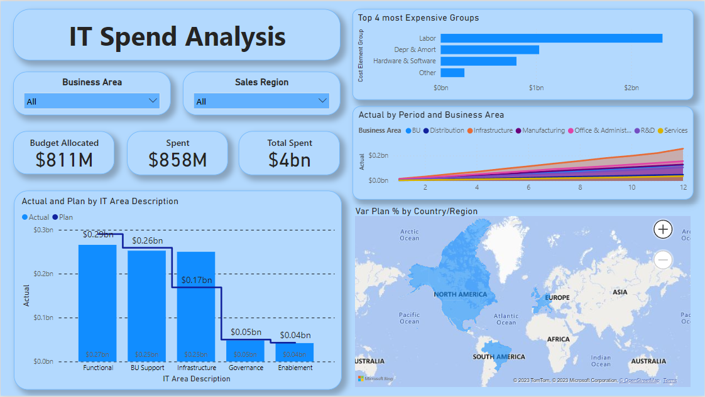

Snapshot of Dashboard:

# **Introduction :**

This Power BI project aims to provide a comprehensive analysis of IT spending. By utilizing various data tables and visuals, we will gain insights into how resources are allocated across different IT areas, regions, cost elements, and business areas. The project focuses on understanding actual spending, planned spending, and variances to make informed decisions and optimize resource allocation.

# **Data Tables Explanation :**

## Date Table :

# The Date Table serves as a time-based framework for the analysis, providing essential date-related information:

* **Date:** Specific calendar dates.
* **Year:** The year associated with each date.
* **Period:** A designation for month number.
* **Month:** Individual months within the year.

## Business Area :

The Business Area table contains data related to different business areas within the organization:

* **Business Area:** Names of distinct business areas.
* **Business Area ID:** Unique identifiers for each business area.

## Cost Element :

The Cost Element table provides information about various cost elements, which are crucial for understanding spending:

* **Cost Element Group:** Groupings of cost elements.
* **Cost Element Name:** The names of specific cost elements.
* **Cost Element Sub Group:** Sub-groupings within cost elements.

## Country Region :

The Country Region table holds data related to countries and regions:

* **Country/Region:** Names of countries and regions.
* **Sales Region:** Sales regions associated with each country/region.

## Department :

The Department table includes information about different departments within the organization:

* **Department:** Names of individual departments.
* **VP:** Vice Presidents associated with each department.

## Fact :

The Fact table is the central source of data for our analysis, providing information on actual spending, planned spending, variances, and other key metrics. It includes the following fields:

* **Actual:** Actual spending figures.
* **Actual/Plan:** The ratio of actual spending to planned spending.
* **Business Area ID:** Unique identifiers for business areas.
* **Cost Element ID:** Unique identifiers for cost elements.
* **Country/Region ID:** Unique identifiers for country/regions.
* **Date:** Dates for the data points.
* **Department:** Names of departments.
* **IT Sub Area ID:** Unique identifiers for IT sub-areas.
* **LE1, LE2, LE3:** Different line items.
* **Plan:** Planned spending figures.
* **Value:** Various financial values.
* **Var LE1, Var LE2, Var LE3:** Variances for line items.
* **Var LE1 %, Var LE2 %, Var LE3 %:** Percentage variances for line items.
* **Var Plan:** Variance from the plan.
* **Var Plan %:** Percentage variance from the plan.
* **YTD Amount:** Year-to-date amounts.

## IT Area

The IT Area table contains information about different IT areas and sub-areas:

* **IT Area Description:** Descriptions of IT areas.
* **IT Sub Area:** Sub-areas within IT.
* **IT Sub Area ID:** Unique identifiers for IT sub-areas.

## Scenario

The Scenario table defines different scenarios that affect spending:

* **Scenario:** Scenario names.
* **Scenario Description:** Descriptions of scenarios.

# **Answering questions using Visuals** :

## Slicers :

Slicers helped us to filter and narrow down our data using categorical variables.

### Business Area Slicer:

Helped us to filter data by different Business Areas.

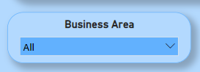

### Sales Region Slicer :

Helped us to analyse the data for different Sales Regions

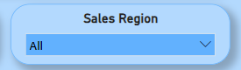

## Cards :

Cards give us the overview of the data. It is used to highlight KPIs, Totals, or any Single Datapoint which needs emphasis in your dashboards.

### Budget Allocated :

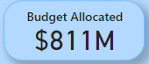

### Amount Spent :

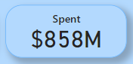

### Total Spent Till Date :

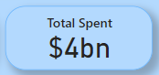

## Where are the top 4 most expensive groups till date?

This visual highlights the top four cost element groups by Year-to-Date (YTD) amount. It identifies the major cost contributors within the organization.

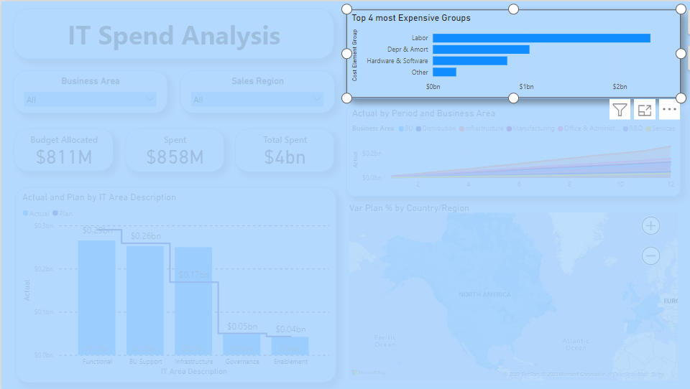

## What is the Amount spent on business areas across periods?

The Area Chart displays actual spending over time (by period) and different business areas. This visualization helps track spending trends within specific business areas.

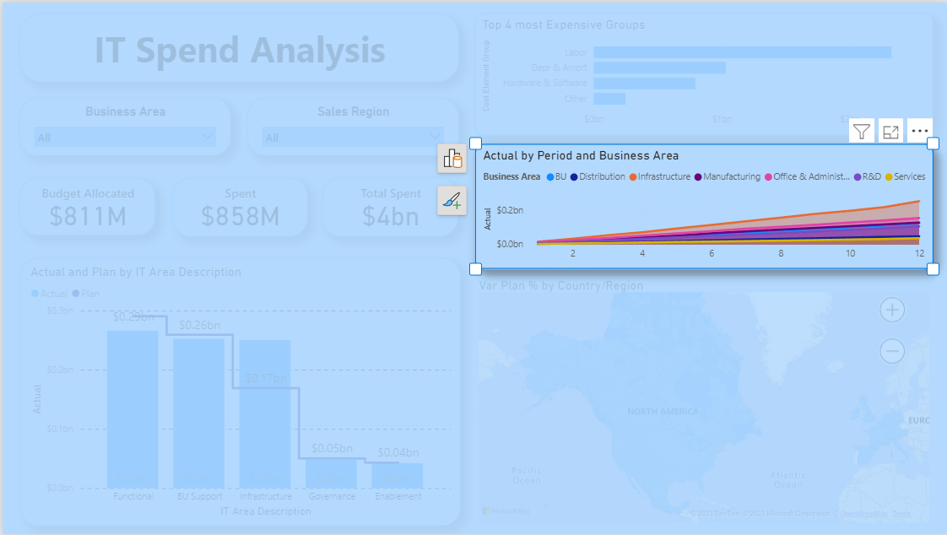

## Compare The allotted price and the actual across IT Areas :

This visual presents a comparison of actual and planned spending across different IT areas. The chart will help identify spending patterns and variances within IT areas.

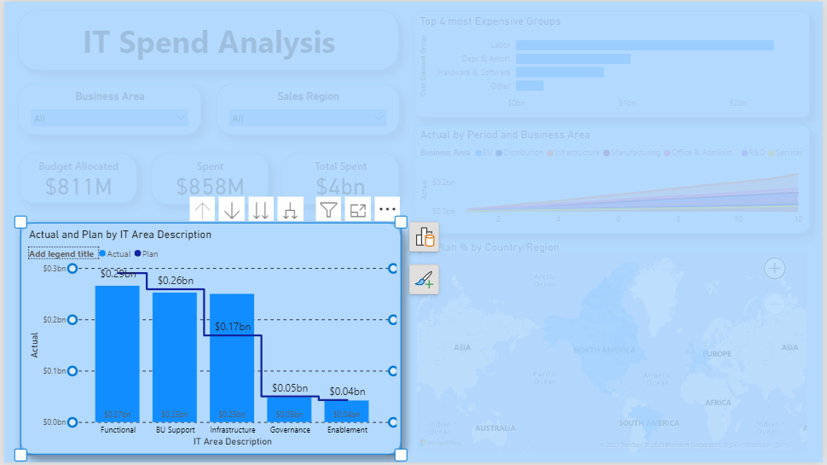

## How do expenditures in each country or region compare to the budget or allocated amounts?

The Filled Map visualizes the percentage variance from the plan by country/region. It provides a geographical perspective on how well spending aligns with the plan across regions.

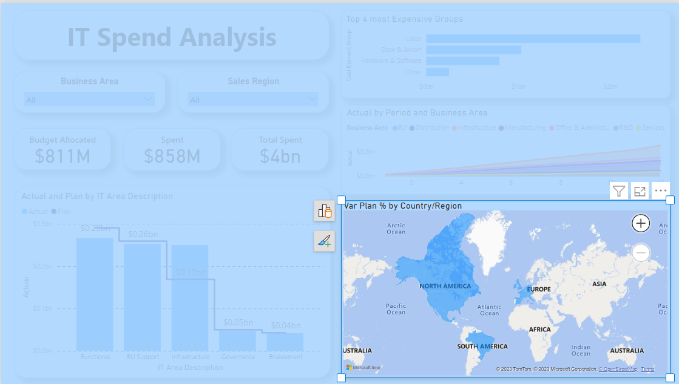

# Conclusion :

The IT Spend Analysis Report offers a comprehensive view of resource allocation and expenditures within the organization. Key takeaways from the report include:

* **Resource Allocation:** The report highlights the distribution of resources across different IT areas, business areas, and regions, showing where investments have been concentrated.
* **Actual vs. Planned Spending:** A comparison between actual spending and planned budgets reveals areas of budget adherence and those where over- or under-spending has occurred.
* **Variance Analysis:** The analysis of spending across different countries and regions provides insights into geographical disparities and informs decisions on resource optimization.